# **How to Deploy a Node.js Applications with Docker:**

* **Application Name: “Awesome Recipes”**

**Step 1: Configure Application Dependencies**

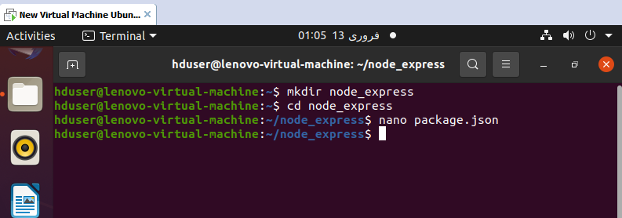

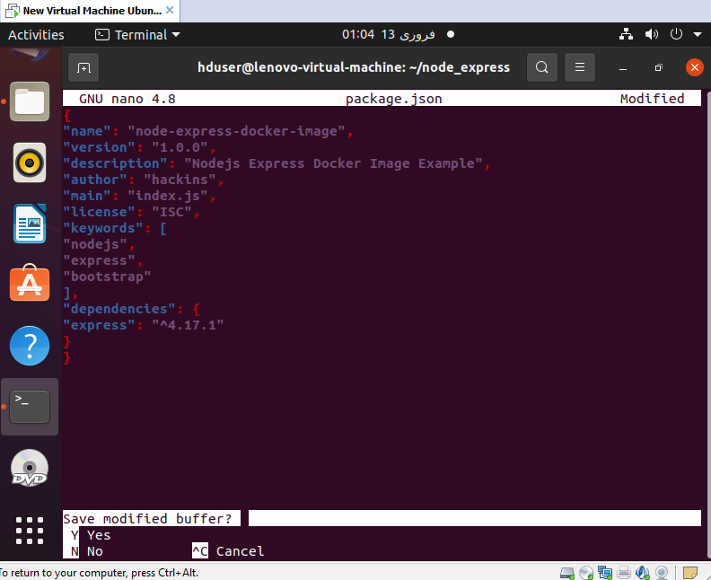

* **Sudo allows a permitted user to execute a command as the superuser or another user**
* **Install npm (Node Package manager): Install for all applications dependencies Like Packages and node modules.**

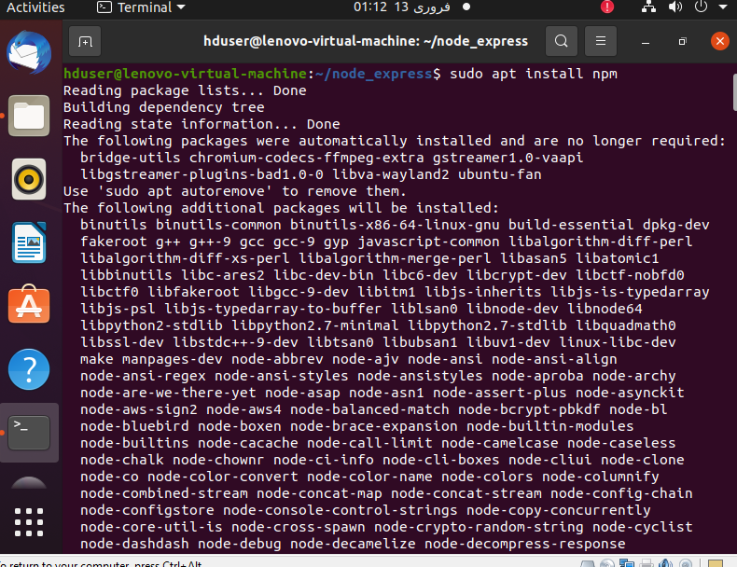

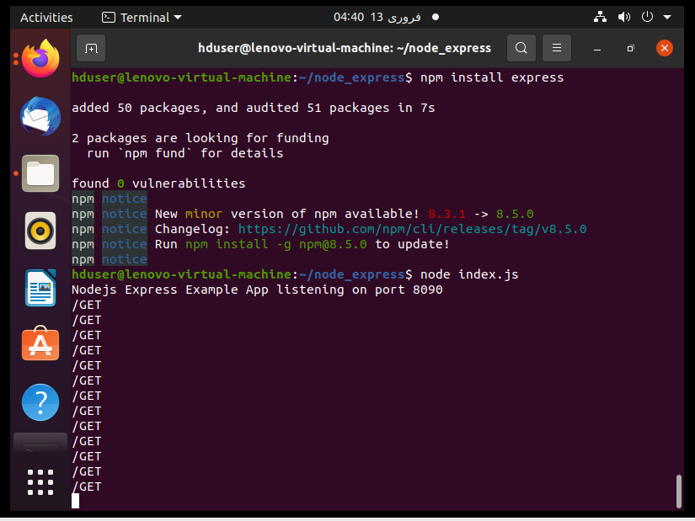

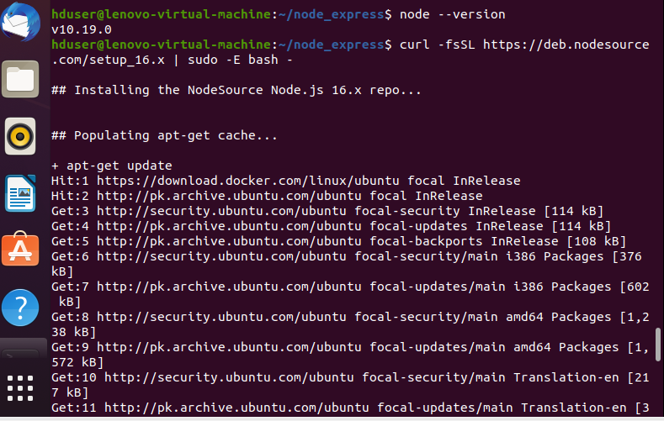

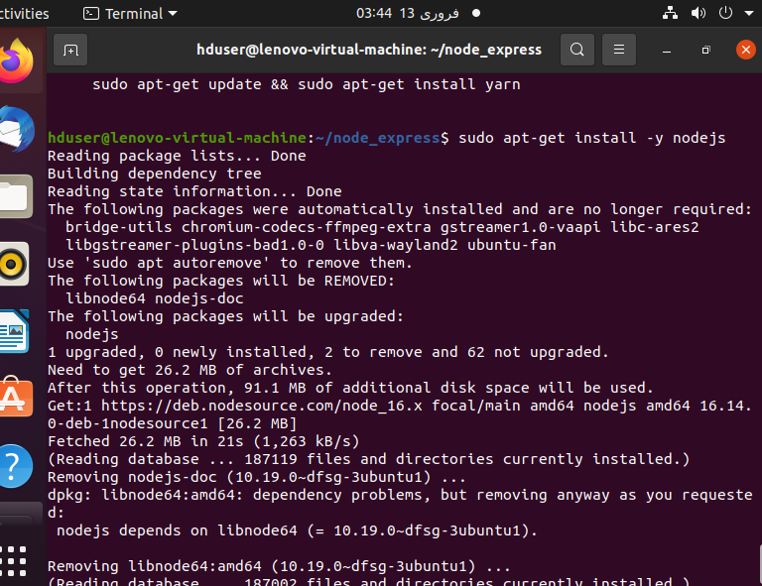

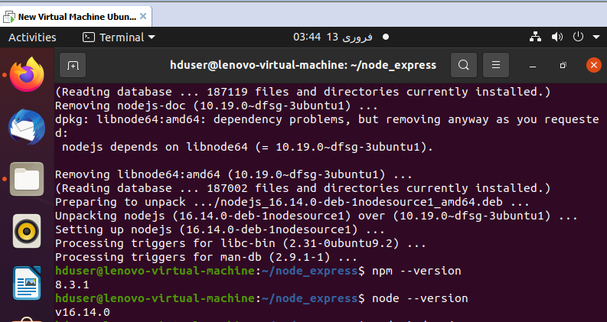

**Step 2: Adding Your Applications Code Files:**

* **Main entry point of application is “index.js”**



* **JavaScript file use to imported module to create the express and router object**
* **We have to set the path define the base directory**
* **We have to set the port (app to listen on port 8090) : Static define**

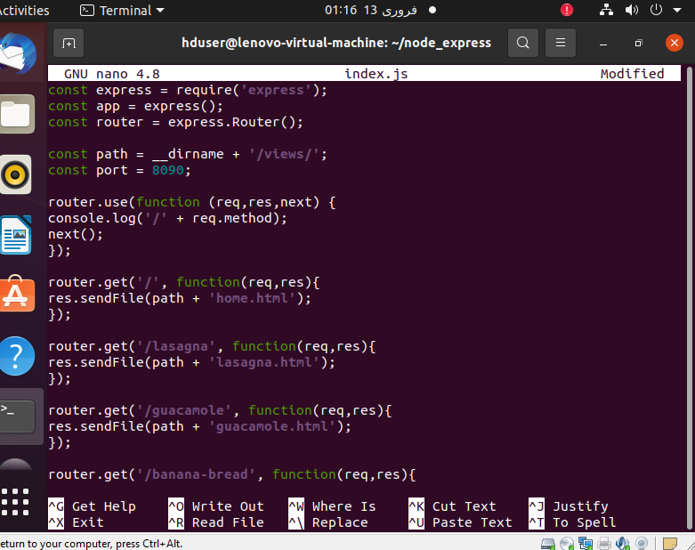

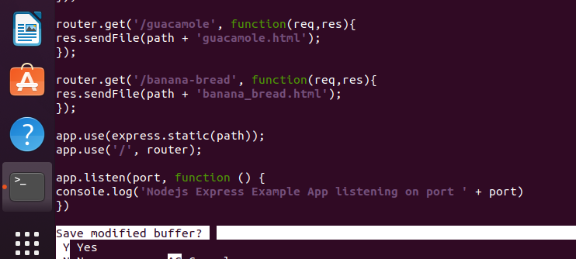

* **Creating home.html (Platform File): To provide bootstraps , and also adds a basic navigations menu to help to move through the page and back to the platform page**

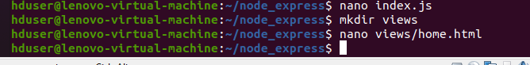

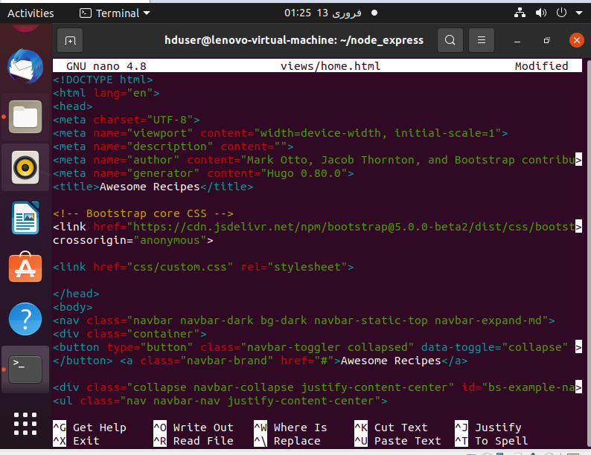

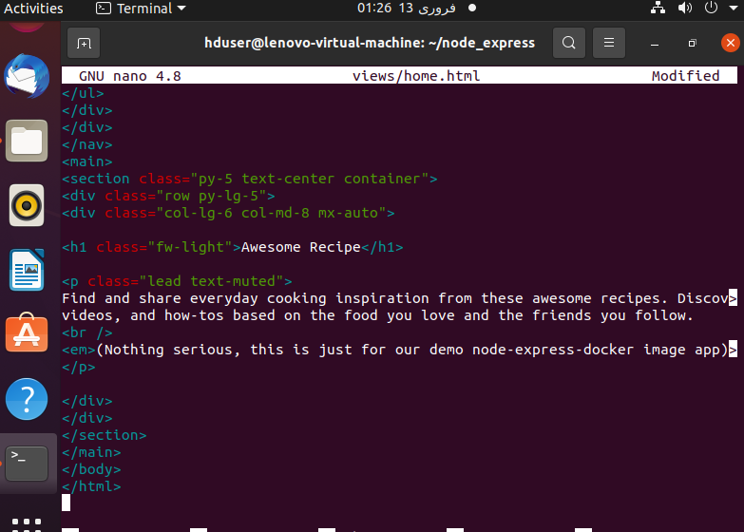

* **Now, let’s create the three pages for the recipes. We first start by creating the lasagna recipes page. Open the file with nano editor using the following command:**

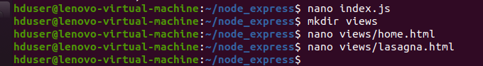

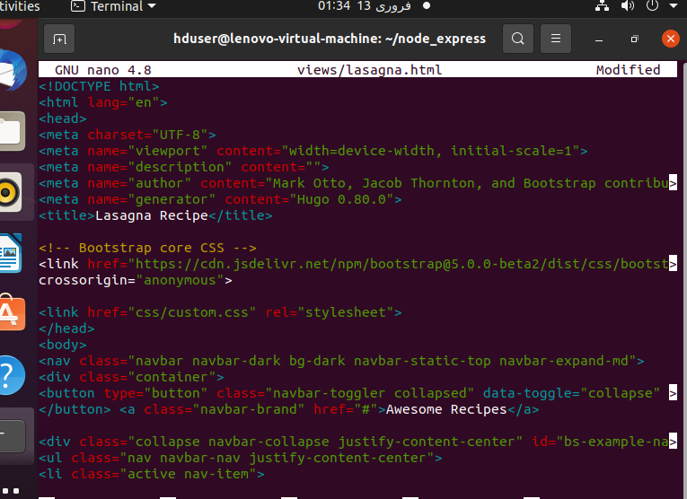

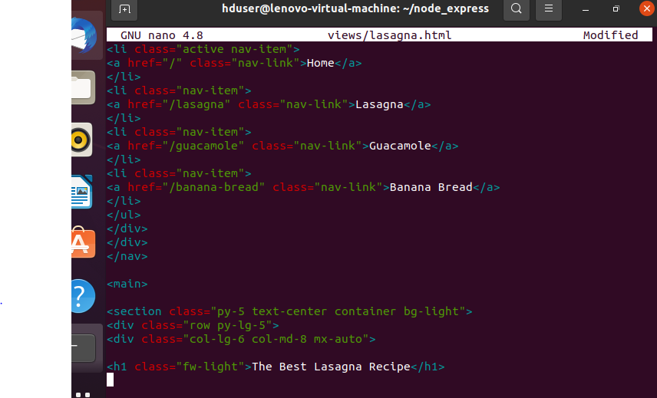

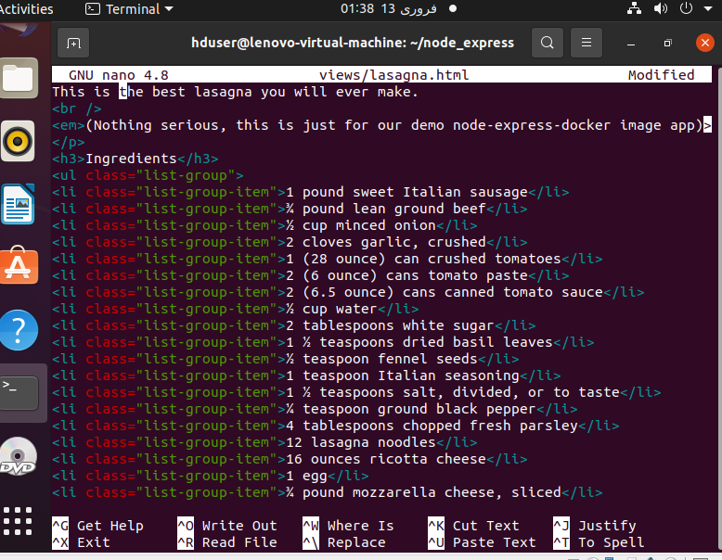

* **Second by creating the guacamole recipes page. Open the file with nano editor using the following command:**

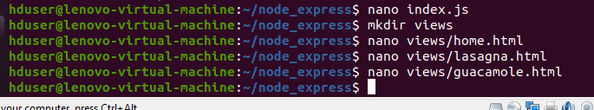

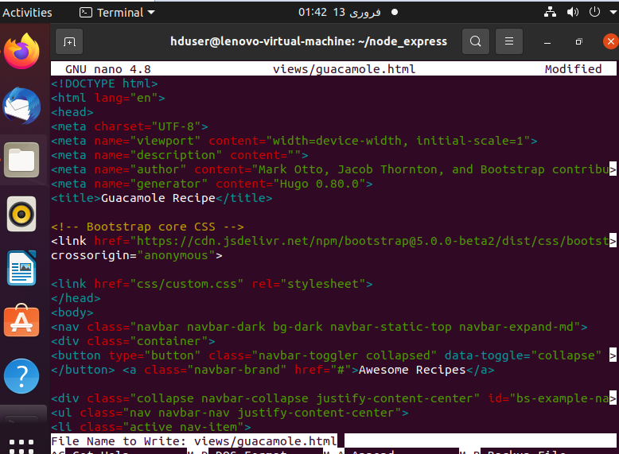

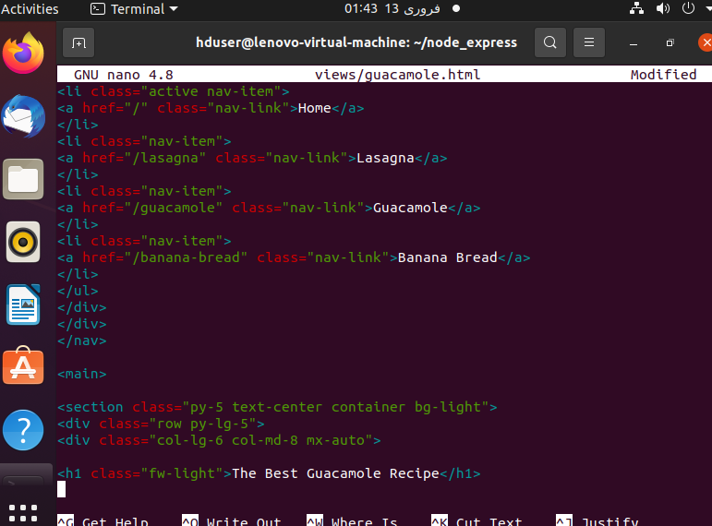

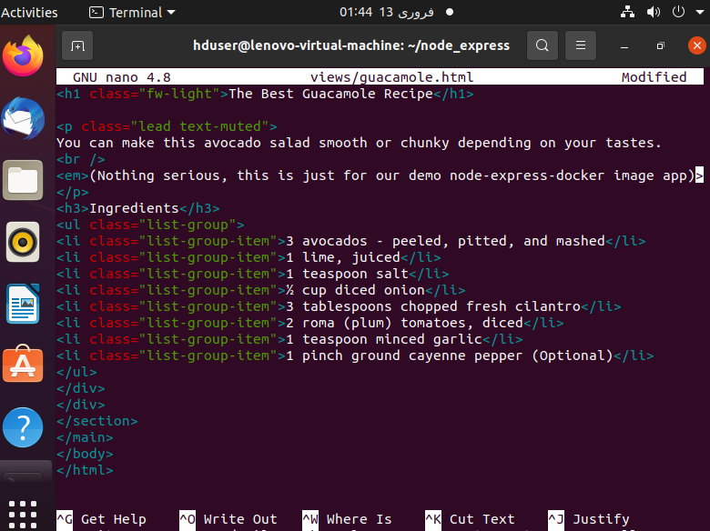

* **Finally by creating the banana bread recipes page. Open the file with nano editor using the following command:**

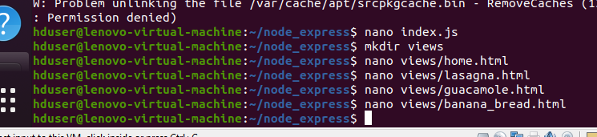

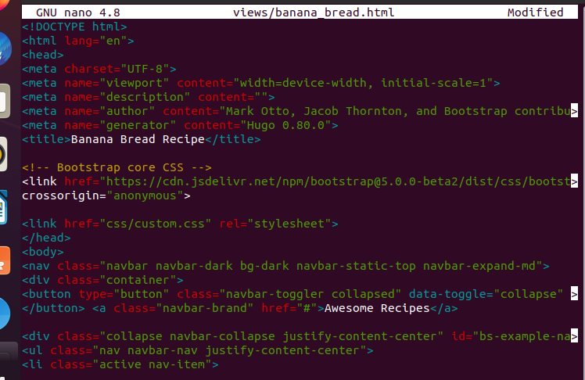

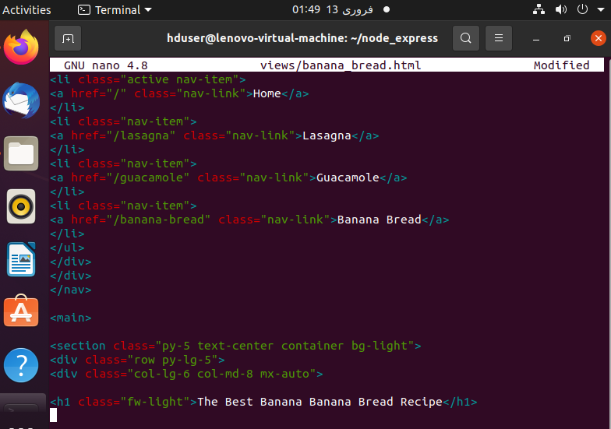

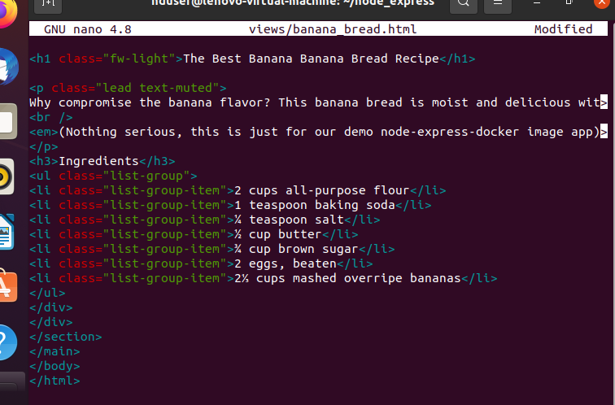

* **Add CSS codes to style your websites as you wish. Open the file with nano editor using the following command:**

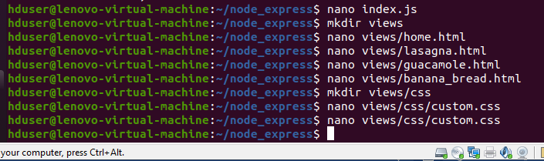

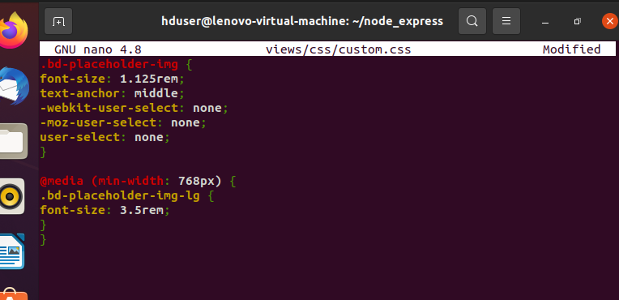

* **Navigate your browser to local host (8090), You will see the recipes Platform Page as defined:**



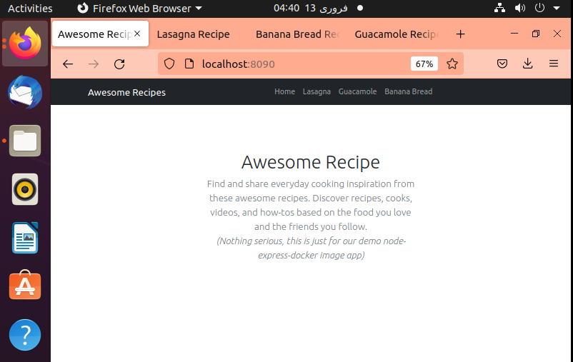

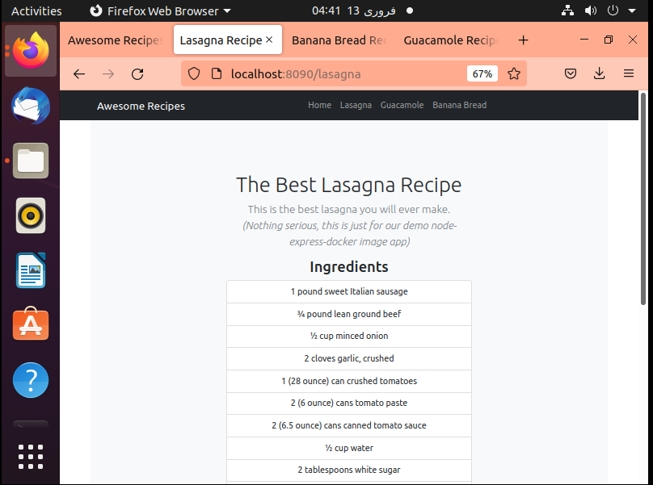

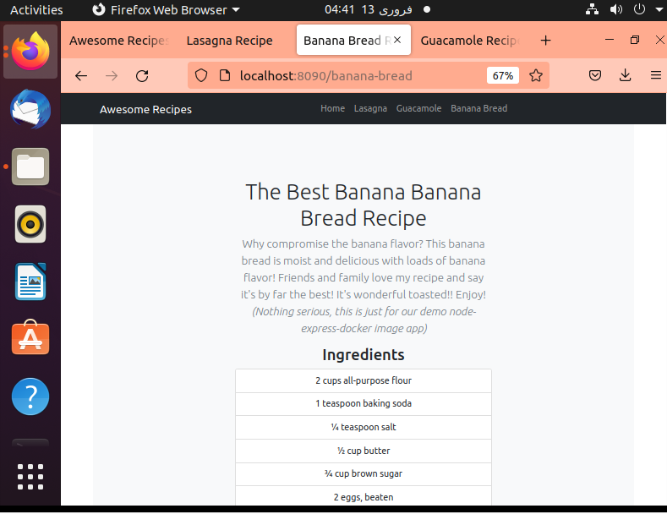

##### Step 3: Creating the Dockerfile:

* **Dockers reads the instructions specified in a Dockerfile when building images. It specifies the runtime environment of an application. Hence, it helps developers avoid with dependencies or changing runtime versions.**

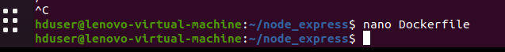

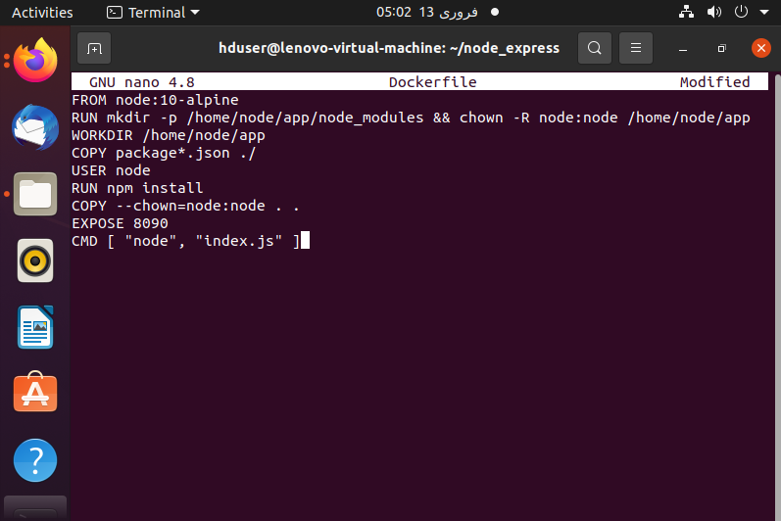

* **.dockerignore specifies which files and directories within the project because directory does not be copied over to the container.**



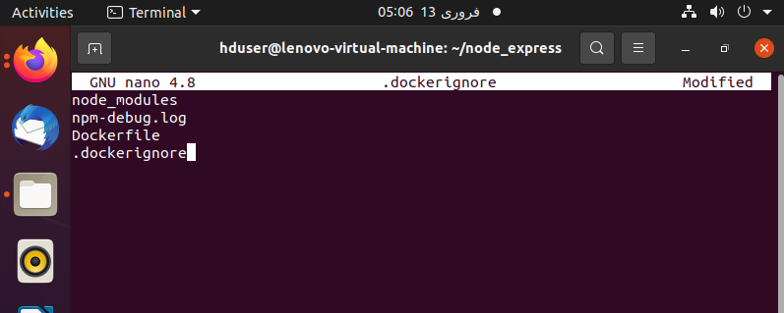

* **Here is the command to build the docker image**
* **Nodejs-express-image is the tag name of your docker image**

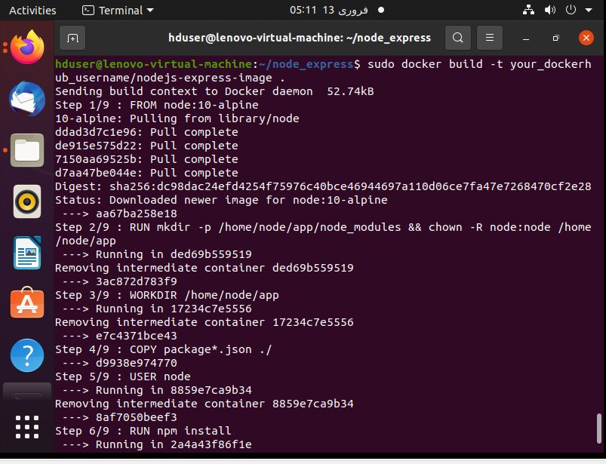

* **Sudo docker images (to show the list of recently created images)**

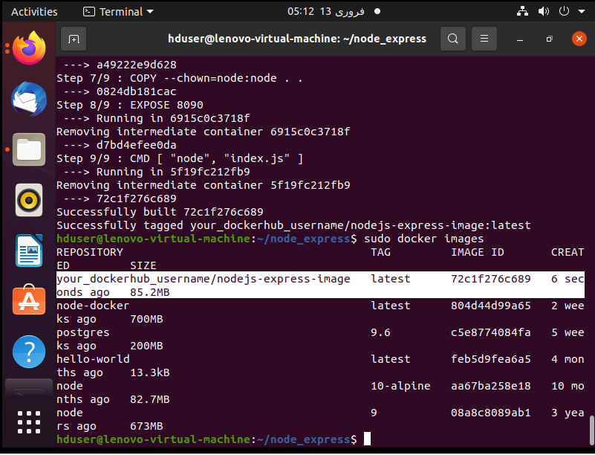

* **To build the container as follow replace your docker hub username**
* **Sudo docker ps( Shows the list of the running containers)**

